Abstract
The GDSC database contains hundreds of thousands of experimental results concerning pharmacological drugs’ impact on cancerous cell lines, and has been used by thousands of scientific articles for both validation of results and preliminary investigation into novel targetting. More recently, the GDSC² database has been released, publishing similar data for combinations of drugs in order to better understand how drugs can work in tandem to achieve better results. Here, we develop, validate and investigate a ‘survivability correlation’ measure between GDSC-tested drugs and DepMap-tested genes, and use this to predict and analyse potential drug pair-gene targets within GDSC². NEED TO ADD KEY RESULTS AND FINDINGS ONCE FINISHED
1 Introduction
Drug-target binding affinity (DTA) is a measure intrinsically linked to the impact of a given drug on cell line viability in lab settings or disease impact in clinical settings. As such, prediction of DTA on a given target, cell line, etc. is a key area of bioinformatics research necessary for better patient responses and is well-discussed in the literature.
Alongside DTA in describing the impact of pharmacological substances on cell populations sits drug combinations. Applying multiple drugs in tandem is commonplace in cancer therapy (Ling and Huang 2020), however, due to the exponentially higher number of potential drug combinations than individual drugs, these effects cannot all be tested experimentally to the same extent. An array of methodologies have been employed aiming to computationally predict combination drug effects, however, these predictions have shown highly limited in applicability (Ling and Huang, 2020).
Here, we approach DTA and drug combination analysis from the perspective of Survivability Correlation (see section 3.3), integrating cell line and drug response information from DepMap, GDSC and GDSC2 alongside PPI network information from STRING to approach these issues from the perspective of statistically-derived drug impacts on genes in place of physical drug-protein interactions.
2 Research Background
2.1 Drug-Target Affinity Prediction
Modern prediction of drug efficacy on cancerous cell lines and tumours employs a number of mechanisms to improve predictive accuracy and therefore patient response and recovery: Machine Learning techniques from Random Forests to Deep Learning (Stroobants et al., 2023); integration of multi-omic data from cells (Lu et al., 2025); knowledge of protein folding and amino acid interaction (Deng et al., 2022). However, these techniques depend on reliable information regarding DTA; i.e. knowledge of what proteins and genes a given drug should impact, and the degree to which they impact them.
Accurate DTA predictions improve drug research efforts, treatment efficacy, and reduce costs. As such, potential improvement is discussed in the literature and improvements are actively under research (Debnath et al., 2025; Wu et al. 2024). DTA prediction traditionally utilises structural information about drugs and target proteins to achieve results, and has increased in complexity and capacity with advances in Machine Learning. GCNs have been employed with molecular graphs (Nguyen et al., 2020) and graph-based protein representations (Jiang et a., 2020), CNNs have been employed to extract information from protein sequences and SMILE representations (Hirohara et al., 2018; Ozturk et al., 2018), which has been combined with LSTM architecture to also encode drug information (Abbasi et al., 2020). More recently, natural language processing (NLP) approaches have been employed, treating drug chemical information as words fed into NLP grammar-based variational auto-encoders which serve as inputs for larger models to integrate this chemical information effectively (Debnath et al., 2025)
However, while encoding and feature extraction of protein and drug structural and functional information is obviously an essential facet of DTA prediction, many of these models fail to leverage available biological data of interaction between drugs and cancerous cell lines, in spite of this data being both available and predictively useful (Koras et al., 2021). Here, we aim to determine the predictability of known drug-gene targets utilising cell line data and more simplistic statistical correlations, use our drug-gene interaction analysis method to predict other drug-gene targets, and investigate the apparent power of combination drug treatment through this DTA prediction lens.
2.2 Drug Combination Effects
A number of studies have found that, as one would expect, certain cancers respond well to multiple anti-cancer drugs being used in tandem as opposed to one individually, and as such are usually employed in a clinical setting (Ling and Huang, 2020; Shouten et al., 2016; Bukowska et al., 2015). Applying combinations of drugs rather than individually has become standard in many fields, from cancer (Humphrey et al., 2011) to hypertension (Glass 2004) to AIDS (Oversteegen et al., 2007), and investigating combinations is a potentially lucrative prospect as novel drug discovery becomes more time-consuming and expensive. Not to mention that more complex diseases are often far more likely to be treatable, if not curable, with multiple drugs targeting key symptomatic areas rather than expecting to discover a single ‘silver bullet’ to any given disease (Pangalos et al., 2007).
Drug combination research is complicated by the lack of an agreed-upon metric for determining drug synergistic effects: Combination subthresholding posits that drug combinations are effective when 2 non-effective drugs reach a statistically significant effect over controls; highest single agent posits combination effects are positive or negative depending on whether the combined effect is higher or lower than the highest-performing drug’s effectiveness; response additivity posits drugs demonstrate synergy when their combined effect is more than their individual effects added together and demonstrate antagonism otherwise; and Bliss Independence is a more complex statistical model viewing drugs as independent actors contributing to probabilistic process (Bliss, 1939; Zhao et a., 2014; Foucquier and Guedj, 2015). And while Bliss Independence is at least the more popular of these, this is without going into alternatives to these ‘effect-based’ strategies for determining drug combination effects.
Additionally, there is debate as to whether drug combinations improve upon single-drug treatment through drug synergy or drugs impacting independent mechanisms contributing to the increased effectiveness, i.e. beneficial additive effects. These two possibilities are sometimes not differentiated in the literature due to both options resulting in increased effectiveness, and their conflation of parlance and statistical differentiation is an ongoing struggle with no clear answers (Foucquier et al., 2015; Frei et al., 1961).
Similarly to in the previous discussion the efficacy of these drug combinations is highly dependent on the cancer tissue and acquired mutations (Nussinov et al., 2021; Lui et al., 2024). Here, we employ our method of determining drug-gene interactions in the case of both individually-acting drugs and their efficacy in tandem, to investigate both how drug efficacy appears to change when drugs are combined, and whether the genes which appear to be targeted are simply a combination of the two individually or more novel.
3 Methodology
3.1 Data Sources
Survivability of cancer cell lines when exposed to numerous pharmacological compounds, or ‘drugs’, was taken from GDSC and GDSC². This data took the form of drug lethality for cell lines when exposed to these drugs, as well as controls. For each drug-gene pair, there were numerous cell lines demonstrating mutations within the given gene. The individual-drug GDSC datasets (GDSC1 and GDSC2) contained 542 pharmacological compounds and their impact on the survivability of 978 cell lines. Utilising CRISPR-derived gene dependency data for each cell line taken from DepMap (Broad, 2025) gives us the correlation between these 542 pharmacological compounds and their interaction with 18,443 genes. Similarly, GDSC² gives us 1,394 different combinations from 88 of these pharmacological compounds and their impact on the survivability of 767 cell lines, allowing for comparison of these combinations and individual drugs and their interaction with 18, 443 genes utilising the CRISPR dependency data.
3.2 GDSC
The Genomics of Drug Sensitivity in Cancer (GDSC) database contains thousands of experimental results exposing known cell lines to numerous pharmacological compounds (Yang et al., 2013). As of now, the GDSC database has been used to some capacity in over 4, 000 articles, being used as data for AI models, integration into larger datasets, reference material for practical experiments concerning specific drugs or genes, and more.
The results found in the GDSC database demonstrate that, even within a given cancer tissue type, different pharmacological compounds, i.e. different drugs, can show radically different responses. This is now a well-known fact, especially in the context of synthetic lethality; PARP inhibitors can show great effectiveness when used in BRCA1/2 mutant breast cancers (Lord and Ashworth, 2017); ATR inhibitors show response against ARID1A-deficient tumours (Williamson et al., 2016); Wee1 inhibitors can target p53-mutant cells (Meng et al., 2021); etc.. However, while a number of specific synthetically lethal links have been identified, the sheer quantity of genes and possible mutations thereof, along with available existing drugs, means that a number of these have potentially not been identified. Especially where these effects are statistically notable but not complete, i.e. given gene mutations increase drug susceptibility but not completely (Nussinov et al., 2021). Finally, this does not take into account the possibility of applying multiple drugs, and thereby targeting multiple genes/proteins, simultaneously.
GDSC² Anchor and matrix data was used. For anchor data, INSERT ANCHOR ISSUES HERE
3.3 Survivability Correlation
DepMap gives information on gene essentiality for each cell line used in GDSC by generating CRISPR knockout versions of the cell lines. This allows us to test the effect of knocking out each gene on cell growth and viability. This gene essentiality data was combined with GDSC cell line data in the form of: drug-gene binding affinity, i.e. pKi values; drug-gene maximum effect values, i.e. eMax values; or natural log of half maximal inhibitory concentration, i.e. ln(IC₅₀) values. The Pearson correlation coefficient between the gene essentially data and one of these GDSC values was then calculated. This gives a single ‘survivability correlation’ giving the relative importance of each pharmacological compound for each gene and vice versa. From this, we obtain a matrix of survivability correlations between pharmacological drugs and genes, or, in the case of GDSC², a matrix between pharmacological drug combinations and genes.
Equation 1: Survivability correlation calculation
where SC represent Survivability Correlation, r(x, y) represents the Pearson’s correlation coefficient between x and y, CL represents a Cell Line, D represents a given drug and g represents a given gene.
Unfortunately, GDSCC does not give binding affinity data; as such, eMax values were used in place of pKi to calculate survivability correlation as these were available for each drug individually and when used in tandem. As such, comparisons between GDSC and GDSCC are not performed in this investigation.
3.4 Survivability Threshold
From this survivability correlation matrix we can extract the correlations for genes per given drug, giving us a distribution of gene survivability correlations for each individual drug. This distribution is used to calculate ‘survivability thresholds’ for each drug; any gene equal to or above the calculated survivability threshold is considered a strong target which the drug affects. See equation 2 below for how these thresholds are calculated.
Equation 2: Survivability threshold calculation
Where mu1, mu2, sigma1 and sigma2 are fitted variables calculated for the curve:
With the survivability threshold calculated, we can determine which genes appear to act as ‘strong’ targets for each drug and vice versa, henceforth referred to as ‘survivability correlation-predicted (SCP) targets’. This can be compared to known drug targets, found through DrugBank, ChEMBL, PubChem, etc., to investigate whether these official targets align with our predictions.
3.5 SCP-true target comparisons
Using the STRING database (Szklarczyk et al., 2023), a PPI network graph can be formed which allows for further investigation. The genes which were found above the Survivability Threshold of a given drug can be located in the STRING network, which allows for both investigation of their own proximity within the PPI network and their distance to chemically identified, known targets of the drug. The former can inform the diversity of biological networks impacted by the drugs tested, while the latter can suggest both the accuracy of SCP targets and whether the drug in question acts directly or indirectly.
3.6 Bliss Independence
Bliss Independence, as described in section 2.1 and defined here in equation 3 below, is designed to give an estimation regarding the synergy when two drugs are used together as opposed to antagonism, with a score above 1 suggesting synergistic effects and a score below 1 suggesting antagonistic effects (Zhao et al., 2014). This is used as a point of comparison between the effects of combining drugs regarding their SC distributions and SCP targets and their apparent efficacy when used together. Note that the version used in this investigation is a more simplified variant which can be applied to the available GDSC² data.
Equation 3: Bliss Independence Score
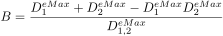
4 Results
4.1 SC distributions
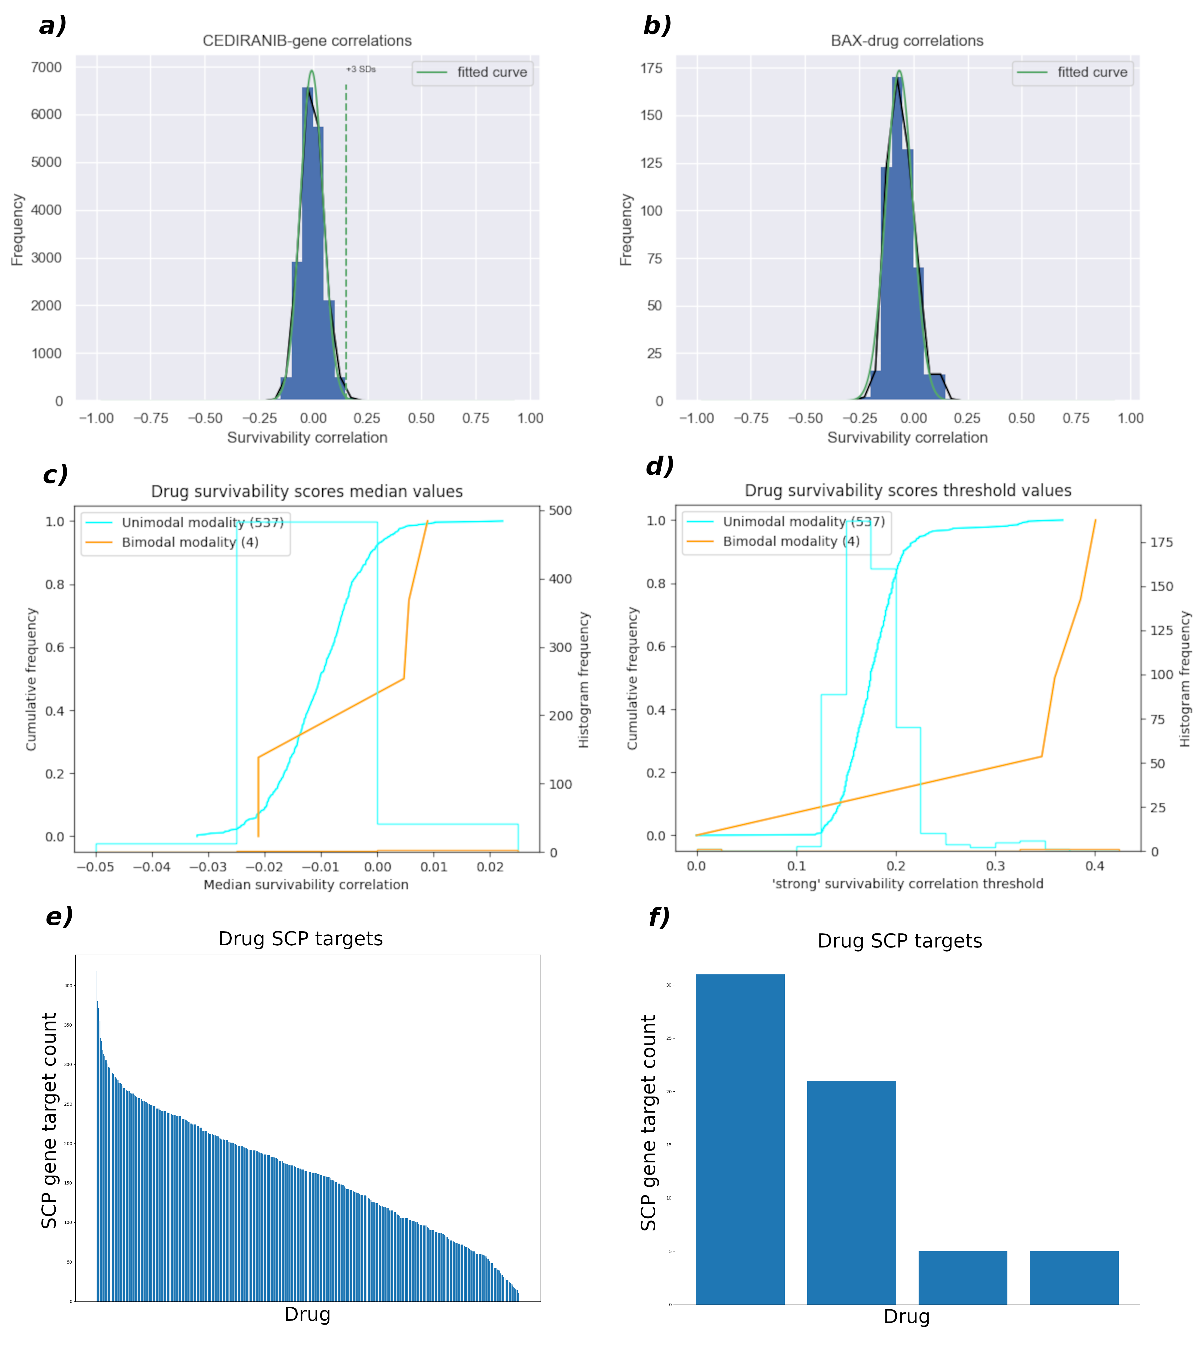
Figure 1: Survivability Correlation distributions.
a) histogram of distribution of SCs of an example drug (in this case Cediranib); the histogram uses 18,443 SC scores from the 18, 443 genes
b) histogram of distribution of SCs of an example gene (in this case BAX); the histogram uses 542 SC scores from the 542 pharmacological compounds (or, more simply, drugs)
c) Cumulative frequency graph of median values of pharmacological compound SC distributions
d) Cumulative frequency graph of threshold values of pharmacological compound SC distributions (as explained in 2.3)
e) Waterfall diagram of SCP target count per drug for drugs with unimodal SC distributions
f) waterfall diagram of SCP target count per drug for drugs with non-unimodal SC distributions

Figure 1 gives a summary of key details for the distributions of survivability correlation scores found in the investigation, as well as relevant information on thresholds and SCP targets found from these thresholds. As can be seen from 1a and 1b, the typical distribution of both drug SC distributions and gene SC distributions is a basic unimodal distribution centred around an SC of zero. Further investigation was constrained to drug distributions as this investigation was more focused on drug impacts on gene/PPI networks rather than gene impactability based on drug similarity. This focus shows that of the 542 pharmacological compounds tested, 537 showed a unimodal distribution, 4 showed a non-unimodal distribution, and 1 did not have sufficient data for the purposes of our tests.
1c shows that median drug SC distributions consistently revolved around a score of 0, with median values rarely extending beyond the -0.03 to +0.02 range. In contrast, 1d shows that the SC threshold varied considerably, from 0.13 to 0.3 for 90% of cases. These two figures show that despite relatively consistent median values around a SC of 0, the range of these distributions varied considerably.
Finally, 1e shows that despite the threshold simply being determined by the median + 3 standard deviations for unimodal distributions, the number of genes considered SCP targets for each drug showed great variability, ranging from less than a dozen genes to more than 400 depending on the drug in question, with most drugs having between 50 and 300 SCP targets. 1f, meanwhile, shows that for the few drugs with bimodal distributions, the more refined formula finds a far smaller number of genes to be SCP targets, with 32 being the maximum and two drugs showing only 4 SCP targets.
4.2 Drug combination results
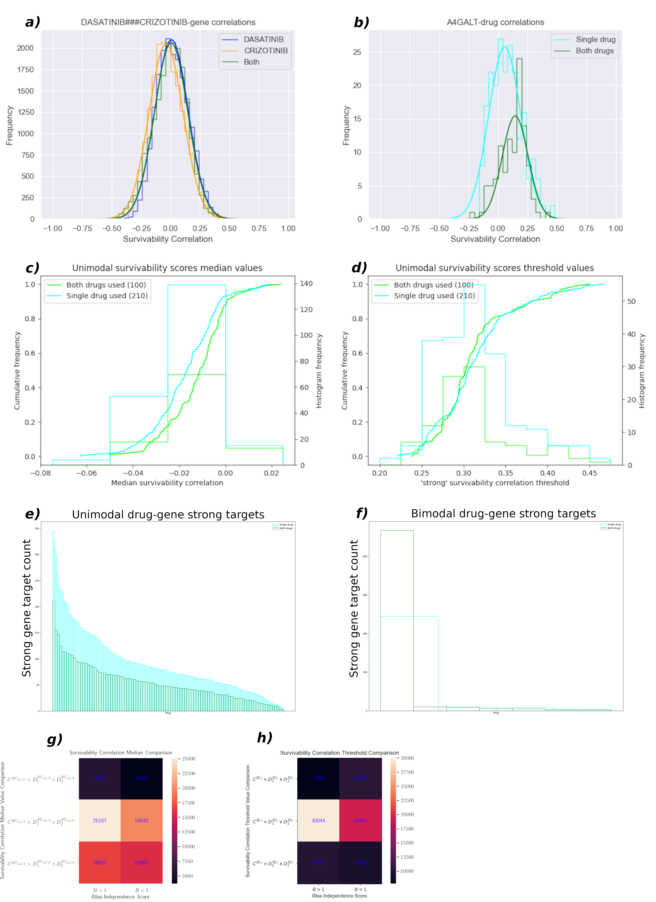
Figure 2: Combination Survivability Correlation Distributions.
a) histogram of distribution of SCs of an example combination (in this case Dasatinib and Crizotinib); the histogram uses 3 sets of 18,443 SC scores from the 18,443 genes
b) histogram of distribution of SCs of an example gene (in this case A4GALT); the histogram uses 1,394 SC scores from the 1,394 drug combinations
c) Cumulative frequency graph of median values of drug combination SC distributions; single drug results and combination results have been separated
d) Cumulative frequency graph of threshold values of drug combination SC distributions (as explained in 2.3)
e) Waterfall diagram of SCP target count per drug/combination for drugs/combinations with unimodal SC distributions
f) waterfall diagram of SCP target count per drug/drug combination for drugs/combinations with non-unimodal SC distributions
g) Confusion matrix comparing median SC value of drug with Bliss Independence value generated per cell line
h) Confusion matrix comparing threshold SC value of drugs and combinations with Bliss Independence value generated per cell line
Figure 2 shows histograms similar to figure 1 in the context of GDSC², comparing the results when using the data from the two drugs in a combination when they act individually and when they act in combination. 2a and 2b show that both single and combination approaches tend to result in a unimodal distribution of SC values. 2c shows that there is a very slight increase in typical median SC values when a combination of drugs are applied, approximately 0.005 to 0.01, though this is not particularly noteworthy as shown by 2g, and 2d shows the opposite occurring in threshold values: a very minor decrease with minimal statistical relevance. 2e and 2f show the number of apparent strong targets for unimodal and bimodal distributions respectively; while a single non-unimodal distribution from a drug combination shows far more targets than all other non-unimodal distributions, generally using combinations of drugs result in less SCP targets than when a drug is used individually, which may (NEED TO UPDATE THIS ONCE WE GET TARGET COMPARISON RESULTS) be of note in 4.3. Finally, the confusion matrices in 2g and 2h compare bliss independence scores, and survivability correlation medians and thresholds respectively. This is done by calculating whether the combination of drugs results in a higher SC median/threshold than either of its component drugs acting individually or not, and then for each cell line tested for that drug, the response Emax’s are used to calculate Bliss Independence, which is binarised to be above 1 (suggesting synergy) or below 1 (suggesting minimal synergy or antagonism). The results show minimal differences between Bliss < 1 and Bliss > 1, though they do show that most drug combinations result in the SC median and threshold values resting between that of their constituent individually-acting drugs.
4.3 SCP-true target comparisons

5 Discussion
5.x Limitations:
Lack of proper controls (non cancerous cell lines) in GDSC data (i.e. impact of each drug on healthy cells)
Heterogeneity of cancer cell lines make DepMap CRISPR gene knockout correlations questionable
5 References
- Abbasi, K., Razzaghi, P., Poso, A., Amanlou, M., Ghasemi, J.B., Masoudi-Nejad, A., 2020. DeepCDA: deep cross-domain compound–protein affinity prediction through LSTM and convolutional neural networks. Bioinformatics 36, 4633–4642. https://doi.org/10.1093/bioinformatics/btaa544
- Bukowska, B., Gajek, A., Marczak, A., 2015. Two drugs are better than one. A short history of combined therapy of ovarian cancer. Contemp Oncol (Pozn) 19, 350–353. https://doi.org/10.5114/wo.2014.43975
- Debnath, K., Rana, P., Ghosh, P., 2025. GramSeq-DTA: A Grammar-Based Drug–Target Affinity Prediction Approach Fusing Gene Expression Information. Biomolecules 15, 405. https://doi.org/10.3390/biom15030405
- Foucquier, J., Guedj, M., 2015. Analysis of drug combinations: current methodological landscape. Pharmacol Res Perspect 3, e00149. https://doi.org/10.1002/prp2.149
- Frei, E., III, Freireich, E.J., Gehan, E., Pinkel, D., Holland, J.F., Selawry, O., Haurani, F., Spurr, C.L., Hayes, D.M., James, G.W., Rothberg, H., Sodee, D.B., Rundles, R.W., Schroeder, L.R., Hoogstraten, B., Wolman, I.J., Traggis, D.G., Cooper, T., Gendel, B.R., Ebaugh, F., Taylor, R., 1961. Studies of Sequential and Combination Antimetabolite Therapy in Acute Leukemia: 6-Mercaptopurine and Methotrexate. Blood 18, 431–454. https://doi.org/10.1182/blood.V18.4.431.431
- Hirohara, M., Saito, Y., Koda, Y., Sato, K., Sakakibara, Y., 2018. Convolutional neural network based on SMILES representation of compounds for detecting chemical motif. BMC Bioinformatics 19, 526. https://doi.org/10.1186/s12859-018-2523-5
- Jiang, M., Li, Z., Zhang, S., Wang, S., Wang, X., Yuan, Q., Wei, Z., 2020. Drug–target affinity prediction using graph neural network and contact maps. RSC Advances 10, 20701–20712. https://doi.org/10.1039/D0RA02297G
- Koras, K., Kizling, E., Juraeva, D., Staub, E., Szczurek, E., 2021. Interpretable deep recommender system model for prediction of kinase inhibitor efficacy across cancer cell lines. Sci Rep 11, 15993. https://doi.org/10.1038/s41598-021-94564-z
- Ling, A., Huang, R.S., 2020. Computationally predicting clinical drug combination efficacy with cancer cell line screens and independent drug action. Nat Commun 11, 5848. https://doi.org/10.1038/s41467-020-19563-6
- Lord, C.J., Ashworth, A., 2017. PARP inhibitors: Science 355, 1152–1158.
- Meng, X., Gao, J.Z., Gomendoza, S.M.T., Li, J.W., Yang, S., 2021. Recent Advances of WEE1 Inhibitors and Statins in Cancers With p53 Mutations. Front. Med. 8. https://doi.org/10.3389/fmed.2021.737951
- Nguyen, Tuan, Nguyen, G.T.T., Nguyen, Thin, Le, D.-H., 2021. Graph convolutional networks for drug response prediction. https://doi.org/10.1101/2020.04.07.030908
- Öztürk, H., Özgür, A., Ozkirimli, E., 2018. DeepDTA: deep drug-target binding affinity prediction. Bioinformatics 34, i821–i829. https://doi.org/10.1093/bioinformatics/bty593
- Schouten, P.C., Gluz, O., Harbeck, N., Mohrmann, S., Diallo-Danebrock, R., Pelz, E., Kruizinga, J., Velds, A., Nieuwland, M., Kerkhoven, R.M., Liedtke, C., Frick, M., Kates, R., Linn, S.C., Nitz, U., Marme, F., 2016. BRCA1-like profile predicts benefit of tandem high dose epirubicin-cyclophospamide-thiotepa in high risk breast cancer patients randomized in the WSG-AM01 trial. Int J Cancer 139, 882–889. https://doi.org/10.1002/ijc.30078
- Szklarczyk, D., Kirsch, R., Koutrouli, M., Nastou, K., Mehryary, F., Hachilif, R., Gable, A.L., Fang, T., Doncheva, N.T., Pyysalo, S., Bork, P., Jensen, L.J., von Mering, C., 2023. The STRING database in 2023: protein-protein association networks and functional enrichment analyses for any sequenced genome of interest. Nucleic Acids Res 51, D638–D646. https://doi.org/10.1093/nar/gkac1000
- Williamson, C.T., Miller, R., Pemberton, H.N., Jones, S.E., Campbell, J., Konde, A., Badham, N., Rafiq, R., Brough, R., Gulati, A., Ryan, C.J., Francis, J., Vermulen, P.B., Reynolds, A.R., Reaper, P.M., Pollard, J.R., Ashworth, A., Lord, C.J., 2016. ATR inhibitors as a synthetic lethal therapy for tumours deficient in ARID1A. Nat Commun 7, 13837. https://doi.org/10.1038/ncomms13837
- Wu, H., Liu, J., Jiang, T., Zou, Q., Qi, S., Cui, Z., Tiwari, P., Ding, Y., 2024. AttentionMGT-DTA: A multi-modal drug-target affinity prediction using graph transformer and attention mechanism. Neural Networks 169, 623–636. https://doi.org/10.1016/j.neunet.2023.11.018
- Yang, W., Soares, J., Greninger, P., Edelman, E.J., Lightfoot, H., Forbes, S., Bindal, N., Beare, D., Smith, J.A., Thompson, I.R., Ramaswamy, S., Futreal, P.A., Haber, D.A., Stratton, M.R., Benes, C., McDermott, U., Garnett, M.J., 2013. Genomics of Drug Sensitivity in Cancer (GDSC): a resource for therapeutic biomarker discovery in cancer cells. Nucleic Acids Res 41, D955–D961. https://doi.org/10.1093/nar/gks1111

